Chapter 1
Introduction to Web and Web Design
- Internet
- Internet is a global communication system that links together thousands of individual networks. It allows exchange of information between two or more computers on a network.
- Internet helps in transfer of messages through mail, chat, video & audio conference, etc.
- It has become mandatory for day-to-day activities: bills payment, online shopping and surfing, tutoring, working, communicating with peers, etc.
ARPANET (Advanced Research Projects Agency Network) was the first computer network that used packet switching to connect geographically dispersed computers and laid the foundation for the development of the internet. It was developed by the United States Department of Defense’s Advanced Research Projects Agency (ARPA) in the late 1960s and early 1970s to connect computers and researchers at various universities and research institutions.
ARPANET was also the birthplace of many of the technologies that are now essential to the modern internet. For example, the first email message was sent over ARPANET in 1971, and the first online chat system was developed on the network in 1973. In addition, ARPANET was the first network to use the TCP/IP protocol suite.

- World Wide Web (WWW)
- The World Wide Web also known as the Web and the Internet are fundamentally dissimilar from one another because the Web is a collection of information that can be accessed using the Internet, whereas the Internet is a global network of networks that offers access to almost all types of information.
- A program that utilizes the internet is called the WWW. It refers to the extensive network of linked online pages.
- Hyperlinks are used to connect these sites. As a result, the user may navigate effortlessly between pages to find the information they need.
- A website is a collection of connected web pages. Accessing webpages or websites on the World Wide Web requires a web browser and the HTTP protocol.
- The HTTP protocol is a collection of guidelines for transporting data on the World Wide Web, including text, photos, audio, video, and other multimedia assets.

- In 1989, Tim Berners Lee began to develop a technology for sharing information via hyperlinked text documents.
- In October-1994 Tim Berners Lee founded an organization called W3C (World Wide Web Consortium) devoted to developing technologies for www. His invention called HTML (Hypertext Markup Language) and the communication protocol HTTP (Hypertext Transfer Protocol) used to send information over the web. (Year-2014-HTML.

- Difference between the World Wide Web and the Internet
Internet | WWW
The Internet allows you to link your computer to any other computer on the planet. | The World Wide Web is a collection of information accessible through the Internet.
The Internet is a worldwide network of interconnected computer networks that connect devices using the TCP/IP protocol. | The World Wide Web refers to HTML-formatted online material that may be accessed using the HTTP protocol.
The Internet can be compared to a large bookstore. | The web can be considered as a store with a collection of books.
Internet is superset of WWW. | The World Wide Web is a subset of the Internet.
It first appeared in the late 1960s. | Tim Berners-Lee, an English scientist, created the World Wide Web in 1989.
The Internet is mostly based on hardware. | In comparison to the Internet, the WWW is more software-oriented.

- Web Browser
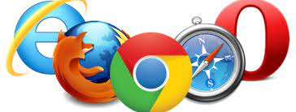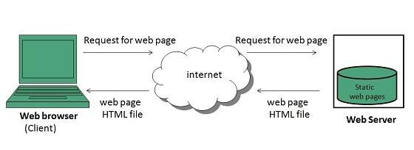
- The web browser is an application software to explore www.
- It provides an interface between the server and the client and requests to the server for web documents and services.
- It works as a compiler to render HTML which is used to design a webpage.
- Whenever we search for anything on the internet, the browser loads a web page written in HTML, including text, links, images, and other items such as style sheets and JavaScript functions.
- Google Chrome, Microsoft Edge, Mozilla Firefox, Safari are examples of web browsers.
- A web browser is used to surf the internet or do online browsing.
- A certain Web site's look may vary slightly depending on the browser being used.

Hyper Text Transfer Protocol(HTTP)
- It is a protocol used to access the data on the World Wide Web (www).
- The HTTP protocol can be used to transfer the data in the form of plain text, hypertext, audio, video, and so on.
- This protocol is known as Hyper Text Transfer Protocol because of its efficiency that allows us to use in a hypertext environment where there are rapid jumps from one document to another document.
- HTTP is used to carry the data in the form of MIME-like format.
MIME (Multipurpose Internet Mail Extensions) is an extension lets users exchange different kinds of data files, including audio, video, images and application programs.

Features of HTTP:
- Connectionless protocol: HTTP is a connectionless protocol. HTTP client initiates a request and waits for a response from the server. When the server receives the request, the server processes the request and sends back the response to the HTTP client after which the client disconnects the connection. The connection between client and server exist only during the current request and response time only.
- Media independent: HTTP protocol is a media independent as data can be sent as long as both the client and server know how to handle the data content. It is required for both the client and server to specify the content type in MIME-type header.
MIME stands for Multipurpose Internet Mail Extensions. It is an internet standard that extends the format of email messages to support text in character sets other than ASCII, as well as attachments like images, audio, video, and other types of files. MIME is widely used in email, but also applies to other Internet protocols, such as HTTP, where it helps define the format of content.
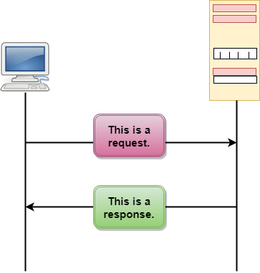
- Stateless: HTTP is a stateless protocol as both the client and server know each other only during the current request. Due to this nature of the protocol, both the client and server do not retain the information between various requests of the web pages.

The figure shows the HTTP transaction between client and server. The client initiates a transaction by sending a request message to the server. The server replies to the request message by sending a response message

Feature | HTTP | HTTPS
Full Form | HyperText Transfer Protocol | HyperText Transfer Protocol Secure
Security | Not secure – data sent in plain text | Secure – data encrypted with SSL/TLS
URL Prefix | http:// | https://
Browser Indication | Shows “Not Secure” | Shows lock icon 🔒
Data Transfer | Anyone can read data (like a postcard) | Data is encrypted (like a sealed envelope)
SEO Ranking | Lower ranking (Google discourages it) | Higher ranking (Google prefers HTTPS)
Use Cases | Old websites, testing environments | Banking, shopping, login systems, all modern sites
Real-Time Example | http://neverssl.com → works but marked “Not Secure” | https://github.com or https://wikipedia.org → secure with lock
- HTTP and HTTPS

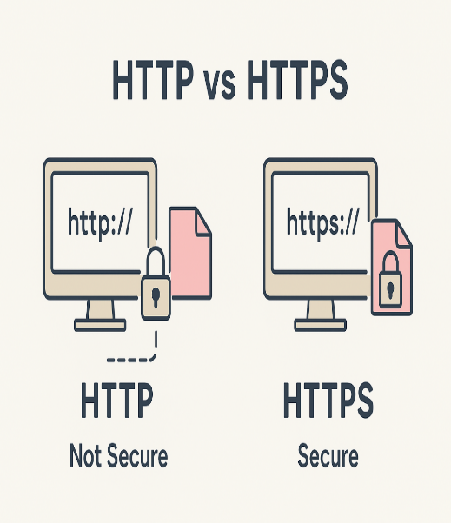

- What is Client-Server Architecture?
Before understanding better client-server architecture, let’s first understand what this client and server are all about.
Client – The client can be any computer that requests something from the server. For example – visiting any website we request the webpage from its domain. So here we act as a client.
Server – On the other hand, the Server is the computer that is designed to serve the requests to the client. The client asks for the webpage then the server responds with the webpage to the client.

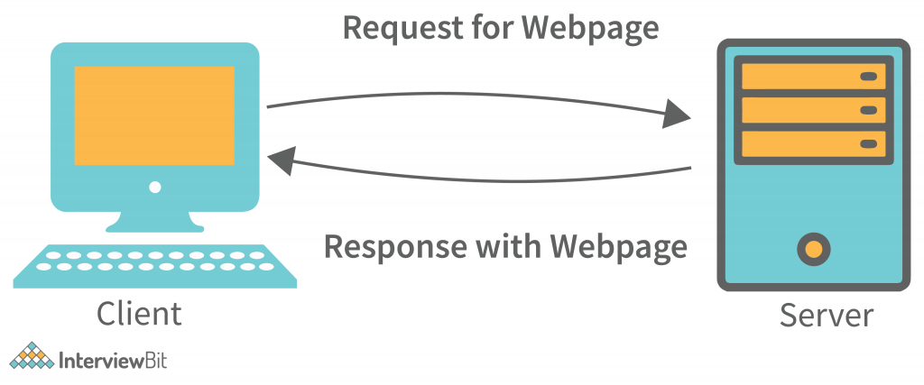
The client-server architecture or model is an application network separating tasks between clients and servers that are either within the same system or need to communicate over a network. In order to access the service provided by the server, the server-client sends the request to another program, which runs a few programs that distribute work among the clients .

- How the browser interacts with the servers?

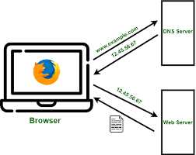

- User opens browser and enters the URL of the website. The Browser then requests the DNS(DOMAIN NAME SYSTEM) Server.
- DNS Server lookup for the IP address of the WEB Server.
- DNS Server responds with the IP address of the WEB Server.
- Browser sends over an HTTP/HTTPS request to WEB Server’s IP (provided by DNS server).
- Server sends over the necessary pages of the website.
- Browser then renders the pages and the website is displayed. This rendering is done with the help of DOM (Document Object Model) interpreter, CSS interpreter and JS Engine collectively known as the JIT or (Just in Time) Compilers.

HTTP Message

HTTP messages are of two types: request and response. Both the message types follow the same message format.
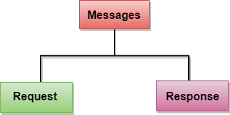

- Request Message: The request message is sent by the client that consists of a request line, headers, and sometimes a body.
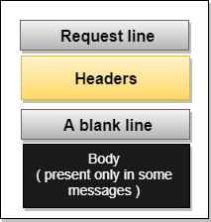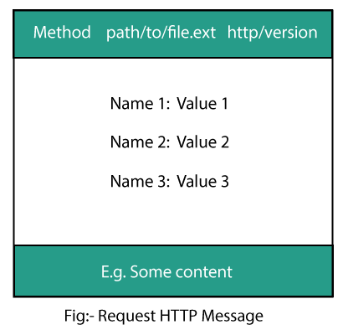

- Initial Request Line
The initial line is different for the request and for the response. A request-line consists of three parts: a method name, requested resource's local path, and the HTTP version being used. All these parts are separated by spaces.
Syntax:
GET /path/to/file/index.html HTTP/1.0
- GET is the most common HTTP method.
- The path shows the part of the URL after the host name. It is also called a request URI.
- The version of HTTP always takes the form “HTTP/x.x”, uppercase.

- Response Message: The response message is sent by the server to the client that consists of a status line, headers, and sometimes a body.
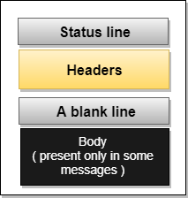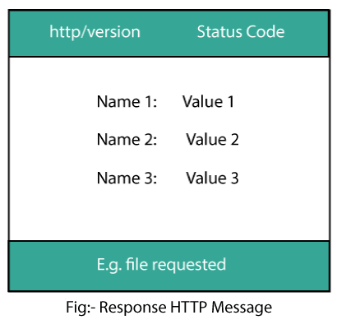

  - Initial Response Line
The initial Response line is also known as the status line. It also has three parts: the HTTP version, a response status code that gives the result of the request, and the English reason phrase describing the status code.
Example:

HTTP/1.0 200 OK
or
HTTP/1.0 404 Not Found
Here,
The HTTP version of the response line and request line are the same as "HTTP/x.x”

- Uniform Resource Locator (URL)
- A client that wants to access the document in an internet needs an address and to facilitate the access of documents, the HTTP uses the concept of Uniform Resource Locator (URL).
- The Uniform Resource Locator (URL) is a standard way of specifying any kind of information on the internet.
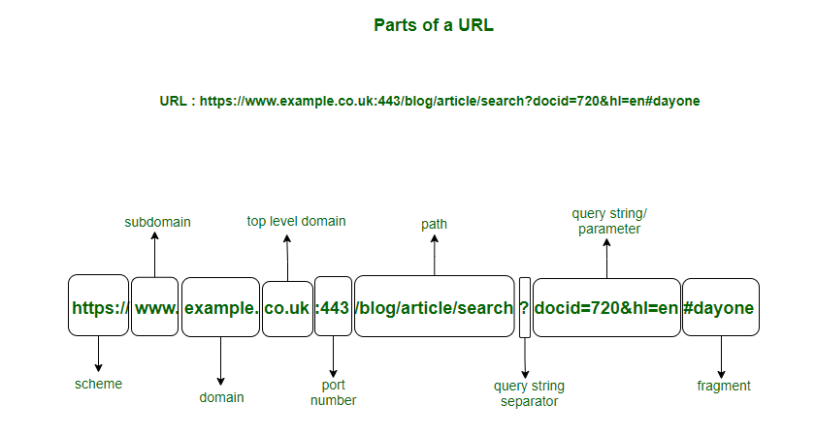

- Scheme/Protocol :
The protocol or scheme part of the URL and indicates the set of rules that will decide the transmission and exchange of data.
- Hypertext transfer protocol (HTTP) – allows users to access data from web pages using hypertext links.
- Hypertext transfer protocol secure (HTTPS) – protects data transmission between the user’s browser and site.
- File transfer protocol (FTP) – used for a file transfer between different devices via a network.
In example https is used. HTTPS stands for Hyper Text Transfer Protocol Secure tells the browser to display the page in Hyper Text (HTML) format as well as encrypt any information that the user enters in the page.
- Subdomain :
https://www.
The subdomain is used to separate different sections of the website as it specifies the type of resource to be delivered to the client. Here the subdomain used ‘www’ is a general symbol for any resource on the web. Subdomains like ‘blog’ direct to a blog page, ‘audio’ indicates the resource type as audio.

- Domain Name :
https://www.example.
Domain name specifies the organization or entity that the URL belongs to. Like in www.facebook.com the domain name ‘facebook’ indicates the organization that owns the site.
- Top-level Domain :
https://www.example.co.in
The TLD (top-level domain) indicates the type of organization the website is registered to. Like the .com in www.facebook.com indicates a commercial entity. Similarly, .org indicates organization, .co.in a commercial entity in the India.
- Port Number :
https://www.example.co.in:443
A port number specifies the type of service that is requested by the client since servers often deliver multiple services. Some default port numbers include 80 for HTTP and 443 for HTTPS servers.
- Path :
https://www.example.co.in:443/blog/article/search
Path specifies the exact location of the web page, file, or any resource that the user wants access to. Like here the path indicates a specific article in the blog webpage.
- Query String Separator :
https://www.example.co.in:443/blog/article/search?
The query string which contains specific parameters of the search is preceded by a question mark (?). The question mark tells the browser that a specific query is being performed.
- Query String :
https://www.example.co.in:443/blog/article/search?docid=720&hl=en
The query string specifies the parameters of the data that is being queried from a website’s database. Each query string is made up of a parameter and a value joined by the equals (=) sign. In case of multiple parameters, query strings are joined using the ampersand (&) sign. The parameter can be a number, string,
encrypted value, or any other form of data on the database.
- Fragment :
https://www.example.co.in:443/blog/article/search?docid=720&hl=en#dayone
The fragment identifier of a URL is optional, usually appears at the end, and begins with a hash (#). It indicates a specific location within a page such as the ‘id’ attribute for an HTML element.

- HTTP status codes
HTTP defines these standard status codes that can be used to convey the results of a client’s
request. The status codes are divided into five categories.
- 1xx: Informational – Communicates transfer protocol-level information.
- 2xx: Success – Indicates that the client’s request was accepted successfully.
- 3xx: Redirection – Indicates that the client must take some additional action in order to
- complete their request.
- 4xx: Client Error – This category of error status codes points the finger at clients.
- 5xx: Server Error – The server takes responsibility for these error status codes.
200 OK
The request succeeded. The result meaning of "success" depends on the HTTP method
301 Moved Permanently
The URL of the requested resource has been changed permanently. The new URL is given in the response.
400 Bad Request
The server cannot or will not process the request due to something that is perceived to be a client error (e.g., malformed request syntax, invalid request message framing, or deceptive request routing).
401 Unauthorized
Although the HTTP standard specifies "unauthorized", semantically this response means "unauthenticated". That is, the client must authenticate itself to get the requested response.
402 Payment Required
This response code is reserved for future use. The initial aim for creating this code was using it for digital payment systems, however this status code is used very rarely and no standard convention exists.
403 Forbidden
The client does not have access rights to the content; that is, it is unauthorized, so the server is refusing to give the requested resource. Unlike 401 Unauthorized, the client's identity is known to the server.
404 Not Found
The server cannot find the requested resource. In the browser, this means the URL is not recognized. Servers may also send this response instead of 403 Forbidden to hide the existence of a resource from an unauthorized client. This response code is probably the most well known due to its frequent occurrence on the web.
502 Bad Gateway
This error response means that the server, while working as a gateway to get a response needed to handle the request, got an invalid response.
503 Service Unavailable
The server is not ready to handle the request. Common causes are a server that is down for maintenance or that is overloaded.
- Concepts of effective Web Design:

Have a Purpose and Plan
- Your website and each page of it should have a purpose and clear specification that what it does. Before you jump to the code figure out what’s your user’s expectation is, what pages they are going to view, what content they are going to read and according to that find out where you want elements to go.

Simplicity
- Complexity is not good in web designing. less-is-more approach work more effectively in web design. Make your website simple and try to display one detail at a time for getting the individual attention of each part.
- Here are some tips for designing a clean and simple website.
- Don’t overload the information at home page on your website. If there is too much content or information, keep them on inner pages.
- Also, make your website consistent in terms of font-family, font-size, colors, images, headings and other aspects.
- Include white spaces in your design. Give enough padding, margin, space between sections, paragraphs, and boxes. It highlights the content and makes your website easy to use.
- Limit the pull-out menus (drop-downs etc.) and avoid using sidebars, sliders, accordions, tabs, and carousels which most of the web designers prefer to include on the website. The user gets distracted and ignores the rest of the useful content on the website
- Readability
- Users should not face difficulty in reading the text on your website so you need to pay attention to the contrast between your text and its background.
- A lot of people use a background image with text over it where the image doesn’t have any overlay and the text gets blended with the image.

Responsiveness
- People use mobile devices for most of their browsing and 50% of web traffic comes from mobile devices.
- These all are the reasons that your application should be viewable on different devices.
Text, layout, images all the elements of your website should be viewable and accessible on different devices for better user experience.

Simple Navigation
- Visitors will definitely move away from your website if they won’t be able to find out the things they are looking.
- Navigation organizes your complete website and guides a user to move around your application.
- The navigation menu should be on the top and sticky on your website so if a user scrolls down the webpage they can still find and access the menu on your website

Call To Action (CTA)
- It’s very important in your website to have a clear call to action button or form that indicates the next step or action user should take on a page to accomplish the task. For example, buy now, sign up, contact form, subscription, registration form, social media button, etc.
- It’s good if you keep your CTA above the fold so the visitor can find it right in front of them.

Load Speed
- People are very impatient and they are not going to wait for too long if your website speed is slow.
- Most of the user moves away from the website within just 5 seconds if they id doesn’t load fast.
- Size of images or videos makes a big impact on website speed so try to compress the image before you add it there.
- Also, combine code into a central CSS or JavaScript file to reduce the HTTP requests.
- Minify HTML, CSS, JavaScript (compressed to speed up their load time).

Pick Up The Right Images
- A picture says a lot about a website and choosing the right image for your website can get a lot of visitors.
- It is recommended to use high-quality optimized images which doesn’t affect your website speed.
- Color Palette
- The color of your website should match the brand of your website.
- When you are choosing colors for your website it should go well with each other also your text should be clear and readable.
- Use a single color for the main element (primary), highlights (secondary) and other less-important elements (background). You also need to keep in mind that your primary, secondary, and background colors should be consistent throughout your entire site.
- Vibrant colors create emotion so it should be used sparingly (e.g. for buttons and call to actions).

- Symptoms of bad design:
- Confusing or cluttered layout: Users are unable to find the information they need in your website. Thus, messy layouts can result in a frustrating experience and ultimately lead to users leaving the site or app
- Poor readability or legibility of text: Text that is too small, poorly spaced, or hard to read can be a significant obstacle for users. It can make the design feel unprofessional and may even discourage users from reading important content.
- Lack of functionality or user-friendliness: Lack of functionality can include broken links, slow loading times, or confusing navigation.
- Unattractive or outdated appearance: A design that looks unattractive or outdated can give users a negative impression of the brand.
- Fails to meet user needs or expectations: A design that fails to meet user needs or expectations can lead to dissatisfaction and disappointment.
- Horizontal scrollbars
- Use of sidebars, sliders, accordions, tabs, and carousels on the website: The user gets distracted and ignores the rest of the useful content on the website.

- Web design issues:
When designing a website, it’s crucial to account for several important aspects to ensure a smooth, user-friendly experience. Below are the main web design issues and their explanations, with some examples where applicable.

1. Simplicity
- Issue: Overloading a webpage with too many animations, a large amount of information, or other distracting elements can overwhelm users.
- Example: A landing page for a blog should not have too many pop-ups, excessive animations, or too much scrolling information. A simple, clear, and minimalist design helps users focus on the content.
- Solution: Minimize animations and present concise, well-organized information. Make the design clean and easy to navigate.

2. Identity
- Issue: The design of a website should align with the nature of the application or brand.

Example: A corporate website like a law firm should use professional and formal fonts, layouts, and color schemes. In contrast, a gaming website can use bold colors, interactive elements, and dynamic graphics.
- Solution: Understand the nature of your website and choose design elements that reinforce the brand's identity.

3. Consistency
- Issue: Inconsistent fonts, colors, or layouts across web pages can confuse users and make the site look unprofessional.
- Example: A website where one page has a red background and a different font size while another page uses blue with a completely different font can disrupt the user experience.
- Solution: Ensure uniformity in design elements such as typography, button styles, and color schemes throughout the website.

4. Robustness
- Issue: Missing content such as broken links, missing images, or incomplete functionality reduces the website's effectiveness and credibility.
- Example: A news website might have broken links to certain articles, resulting in a 404 "Page Not Found" error.
- Solution: Regularly test for broken links and missing content. Tools like W3C Link Checker can help identify and fix broken links.

5. Compatibility
- Issue: Websites need to work seamlessly across various browsers and operating systems.
- Example: A website that works perfectly in Chrome may look distorted or fail to load correctly in Firefox or Edge.
- Solution:
  - Follow W3C standards: Ensure your HTML and CSS follow web standards to prevent rendering issues across different browsers.
  - Validate the code: Use tools like the W3C Markup Validation Service to ensure your code is error-free.
  - Test on multiple browsers and devices: Test your website on various browsers like Chrome, Firefox, Edge, and Safari, as well as on different devices.

1) Browser Compatibility Issues
Websites should render properly across different browsers (Chrome, Firefox, Edge, Safari). Failure to do so can result in distorted layouts, missing functionality, or pages that don’t load.

How to Solve Browser Compatibility Issues:
- Follow W3C standards: Ensures consistent rendering.
- Validate the code: Detect errors that might lead to browser compatibility problems.
- Know your audience: If most users use a specific browser, prioritize compatibility for that browser.
- Test your website: Regularly check on different browsers and operating systems.

Example:
A CSS property like flexbox works well in modern browsers like Chrome and Firefox but might render differently in older versions of Internet Explorer. Using standardized code and browser-specific fallbacks (such as using @supports in CSS) can ensure cross-browser compatibility.

2) Bandwidth Issue
- Issue: Users with slower internet connections (low bandwidth) will experience longer load times if a webpage has many images, videos, or other large files.
- Example: A news site with many high-resolution images or videos will load slowly on a mobile network or slow broadband connection.
- Solution: Optimize images and compress resources. Tools like TinyPNG or image compression via CSS/JS can reduce image sizes. Use lazy loading for images and other large media files to only load them when needed.

3) Cache
Cache refers to a browser’s temporary storage for web pages and images. When a user visits a website, the browser stores some of the site’s data in its cache. On the next visit, the browser tries to load the page from the cache rather than downloading everything again, which makes the page load faster.
- Issue: Sometimes changes made to a website are not immediately reflected for users because their browser loads the cached version.
- Example: If a website's logo is changed, but users still see the old logo due to cached data.
- Solution: Set cache headers appropriately or provide users with the option to refresh the cache by adding versioning to resources (e.g., logo-v2.png).

4) Display Resolution
Different devices have different display resolutions, and web pages must be designed to scale well across various screen sizes.
- Issue: A site designed for a 1280x720 resolution may look too small or too large on other screen resolutions, leading to awkward layout issues.
- Example: On a mobile device, a desktop-designed website might require zooming in and out, making navigation difficult.
- Solution: Use responsive design with CSS media queries to make the website adaptable to different screen sizes. Frameworks like Bootstrap help create mobile-friendly, responsive websites that adjust to various screen resolutions.

- Designing Effective navigation
1. Don’t Make your Users Guess!
It is sometimes necessary to spoon feed your visitors with information. Make careful decisions as to where your navigation is placed, and make it stand out.
2. Keep it high
Newspaper editors place their most important information — latest headlines, significant content, etc — ‘above the fold’, meaning in the top half of the newspaper itself.
Consider your pages from the same perspective, and keep the significant information, including the navigation, as high up as possible.
3. Below the Banners
Users naturally ignore content placed above any banner ads on your site — they simply consider this space for further advertisement. So don’t place any navigation elements above your banner ads.
4. Consistency is Key
All the linked pages of your website locate the navigation in the same place, with the same styles and font. So, users know exactly where to look for it.
5. Don’t be Adventurous
It’s always good to see your site stand out from the crowd. But when it comes to navigation, try to make it simpler as other websites. So, users won’t need to be taught anything new.
6. Add a ‘Home’ Button
Your home page is the most important page on your site, so make sure your users always know how to get back to it. Allow people who land on sub-pages within your Website to find your home page link from those subpages.

7. Keep it Fast
It is not necessary that all your users have super-fast Internet connections. Despite this fact users want to see fast loading pages wherever possible. So, optimize your images, your HTML and your stylesheets to ensure everything loads as fast as possible.
8. Quality, not Quantity
Build your navigation so that it gives users more and more specific information. Internet users are a lot happier with a few choices of navigation buttons. Use subsections and subcategories with appropriate navigation to enable users to quickly locate the specific content they want.
9. Browser Compatibility
People use other Web browsers and resolutions to the ones you use. Check site’s navigation in all possible browsers and resolutions before you launch.
10. Leave Out the Unimportant Stuff
Link such as ‘Privacy Policy’ should not be the part of Website’s main navigation. The most common place for it to go is at the footer section of the page.

- Look and Feel of Website:

- Each webpage should be decorated, well-formatted, and attractive.
- Support for multimedia (images, video, audio).

Page Layout & Linking
Page layout arranges visual elements to improve appearance, flow of information, and user experience.
Main Sections:

- Header → top area of the page.
- Navigation bar → menu with links.
- Index/Sidebar → optional extra info or ads.
- Content Section → central area for main content.
- Footer → bottom with contact/info.
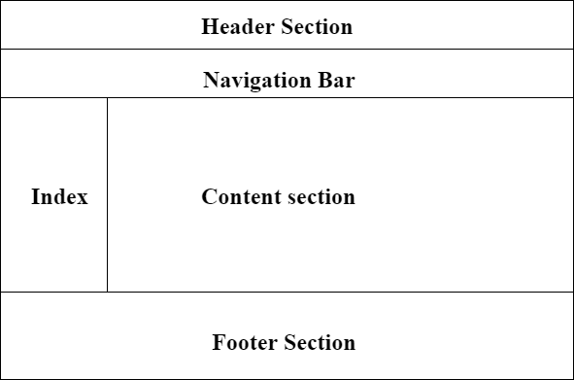

Types of Layouts
- Flexible (Fluid)
- Uses percentage widths, adjusts with screen size (e.g., Wikipedia).
- Responsive but text lines can get too long on wide screens.
- Fixed
- Has consistent width/height, centered on screen.
- Layout remains the same across all resolutions.

Header
Navigation  33% | Navigation  33% | Navigation  33%

